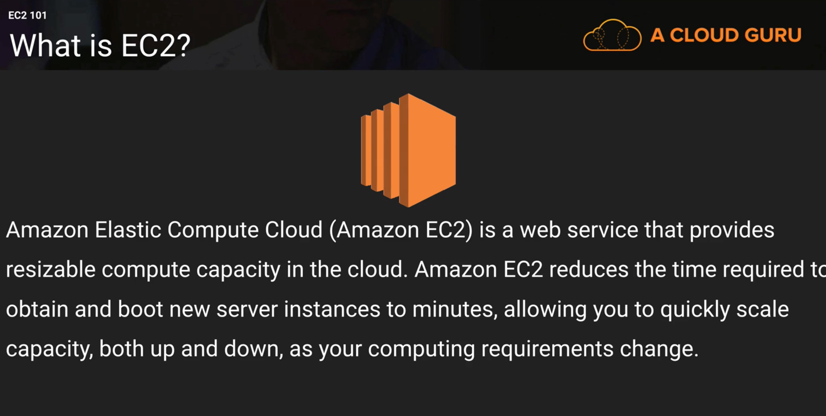

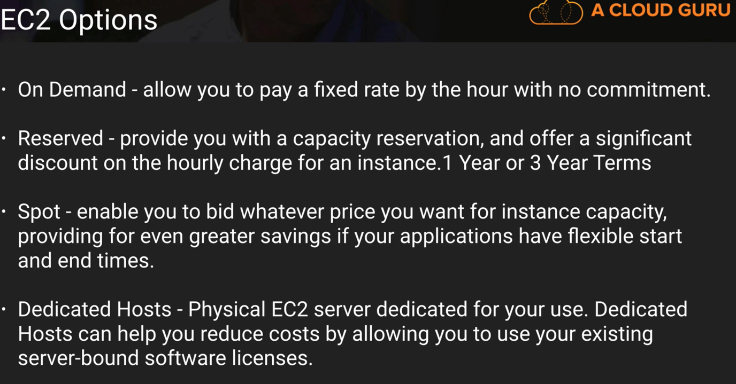

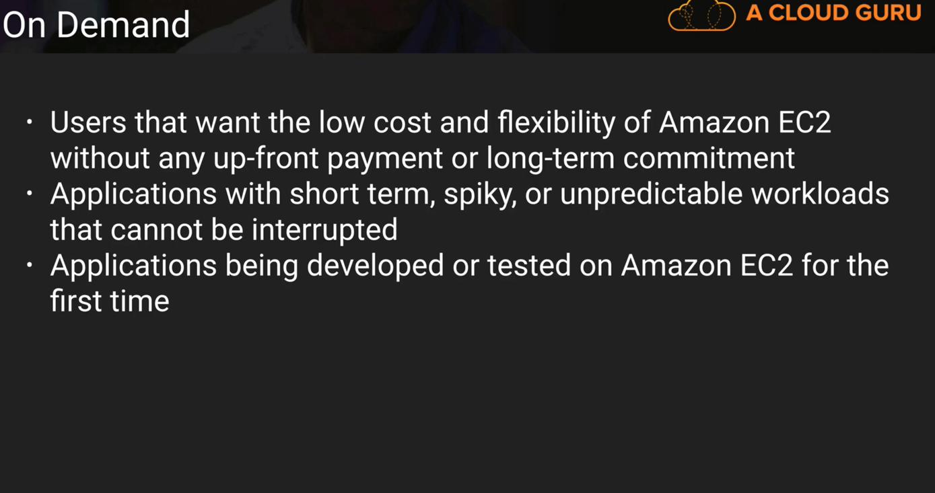

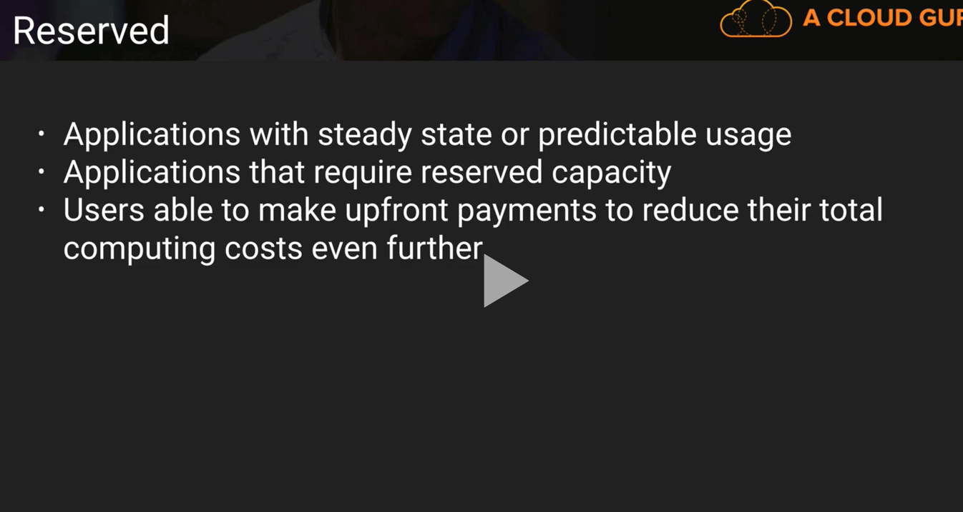

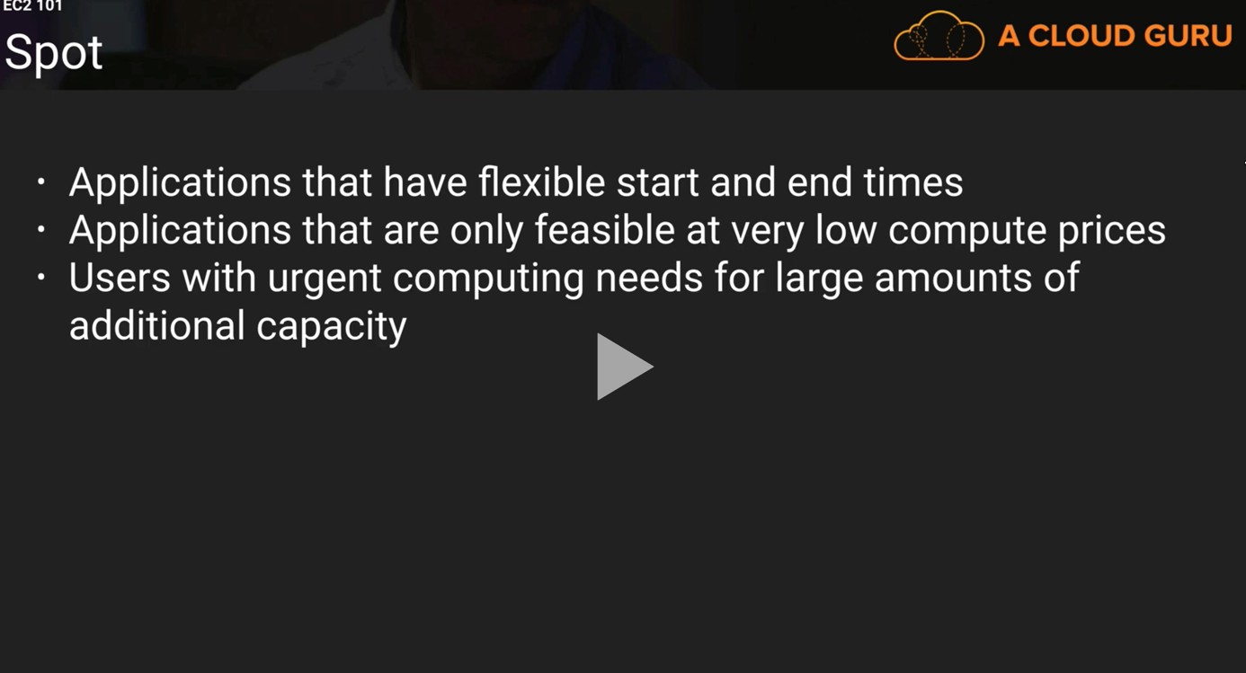

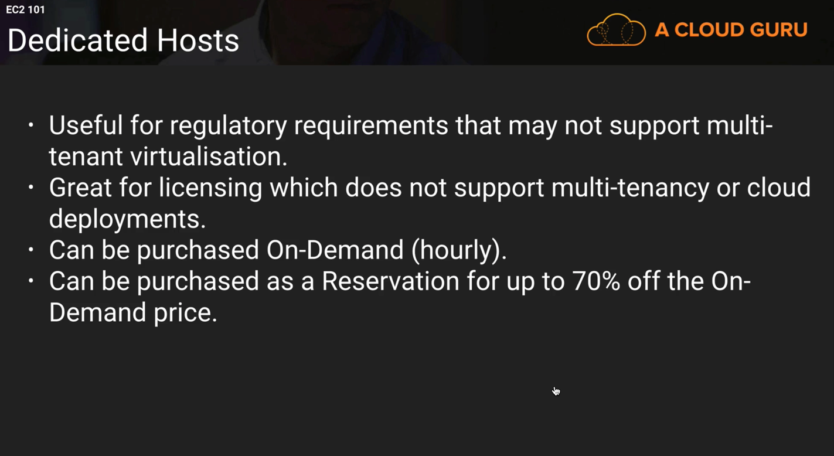

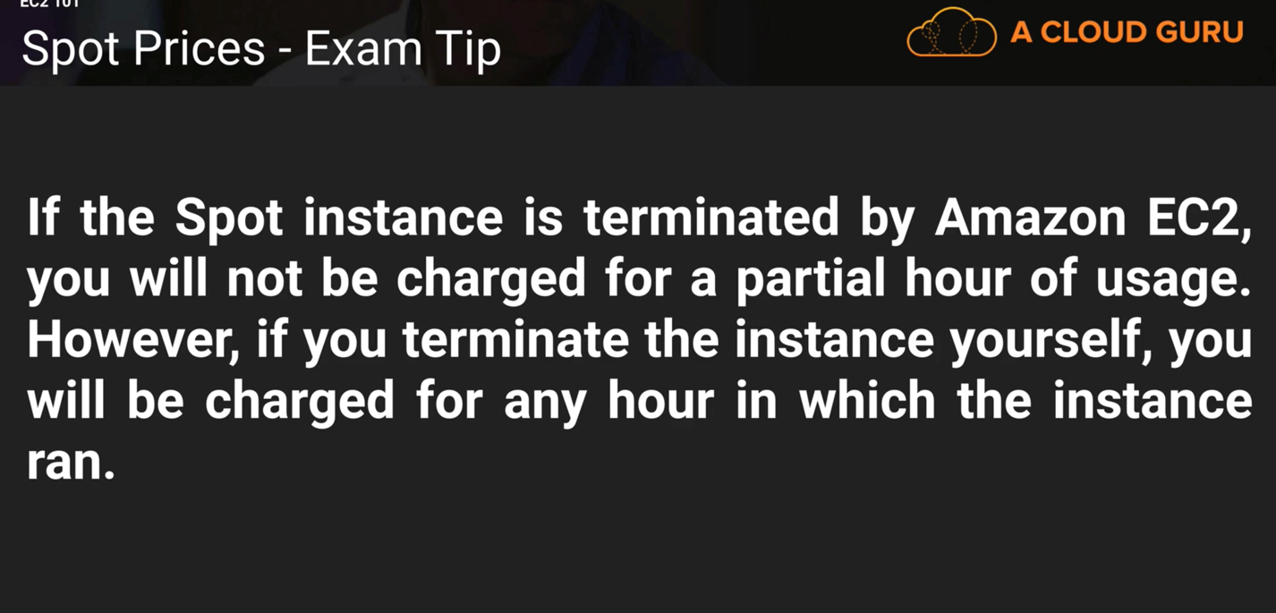

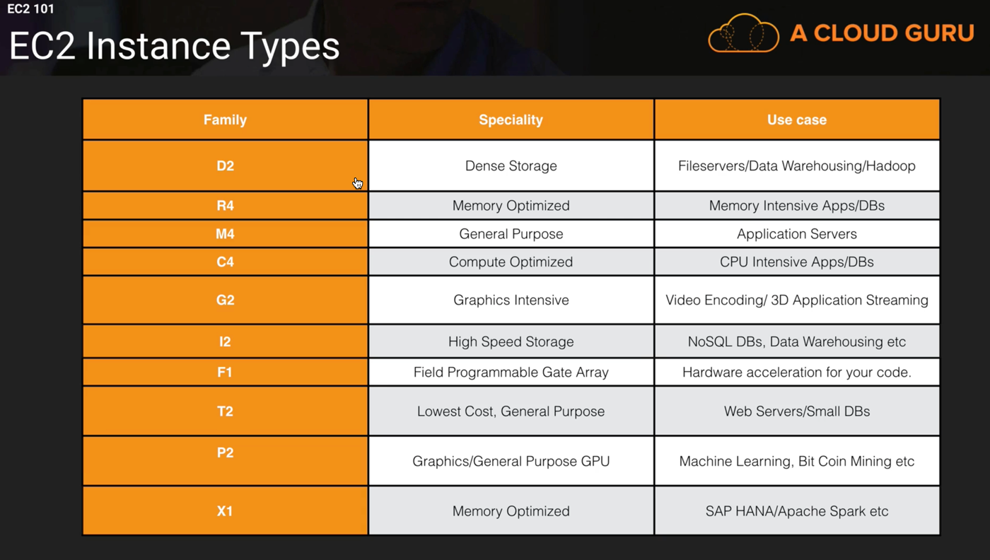

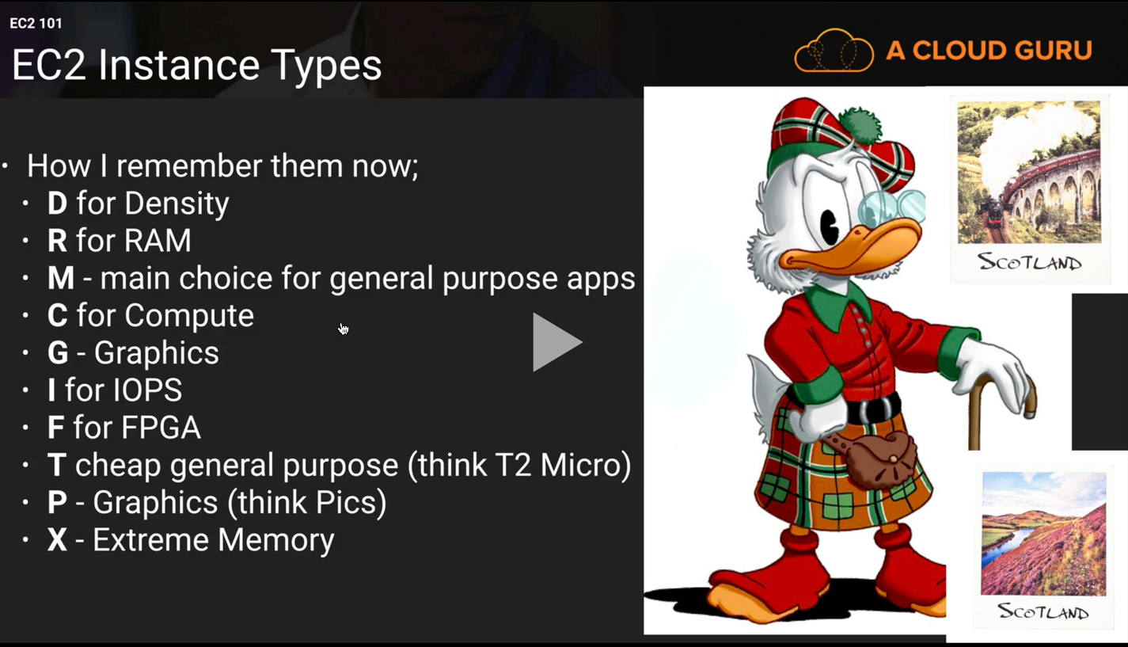

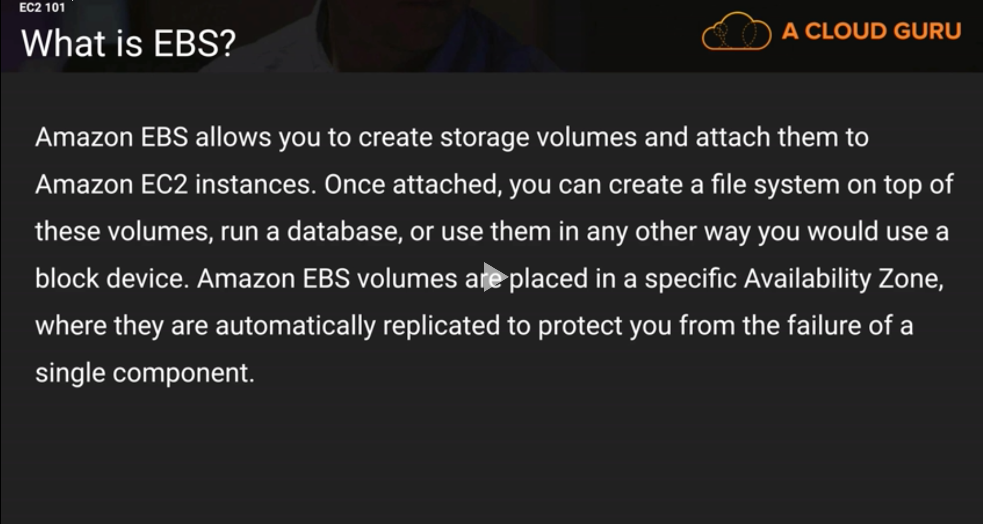

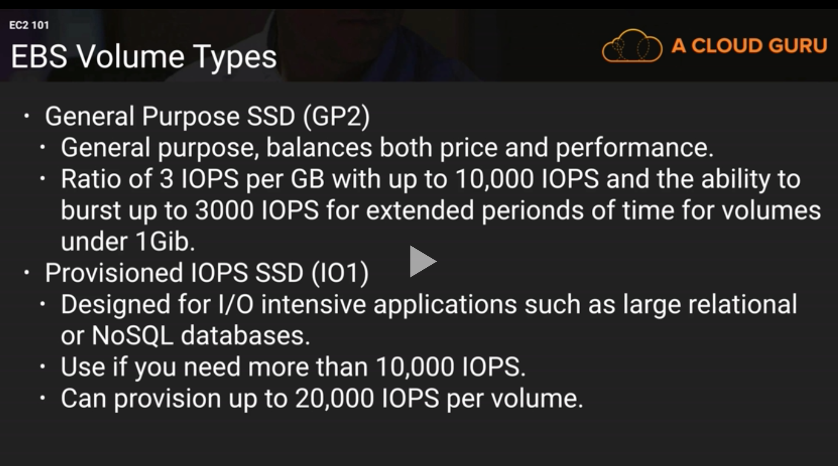

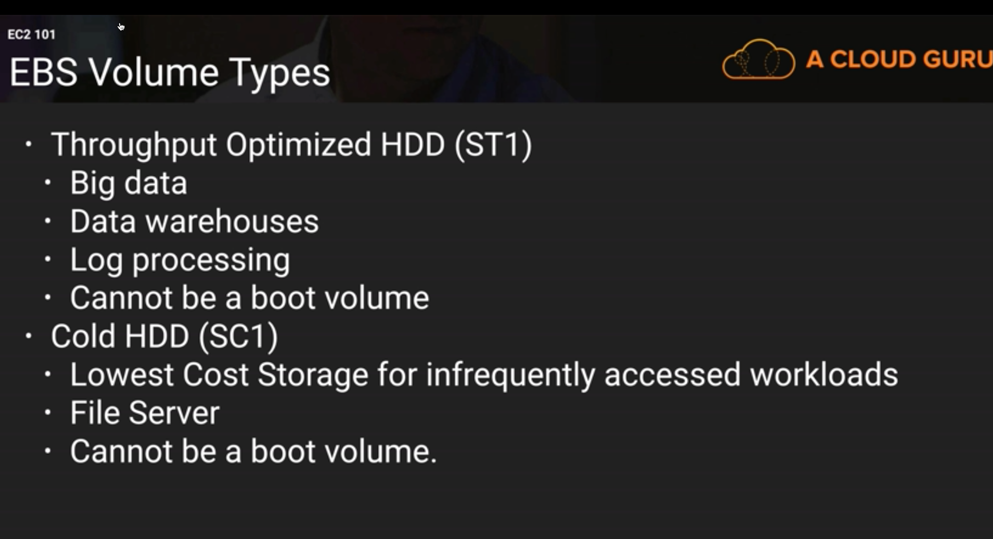

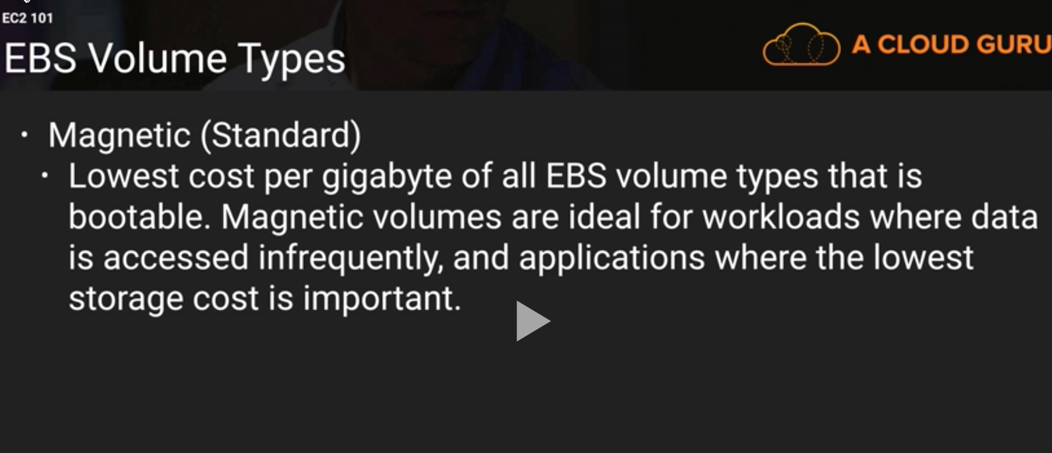

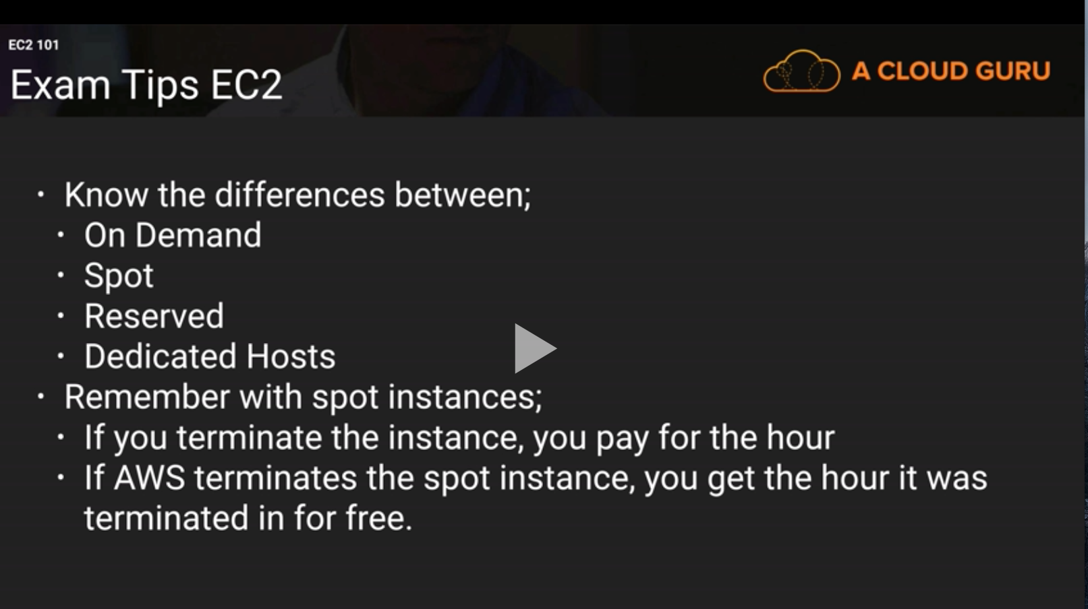

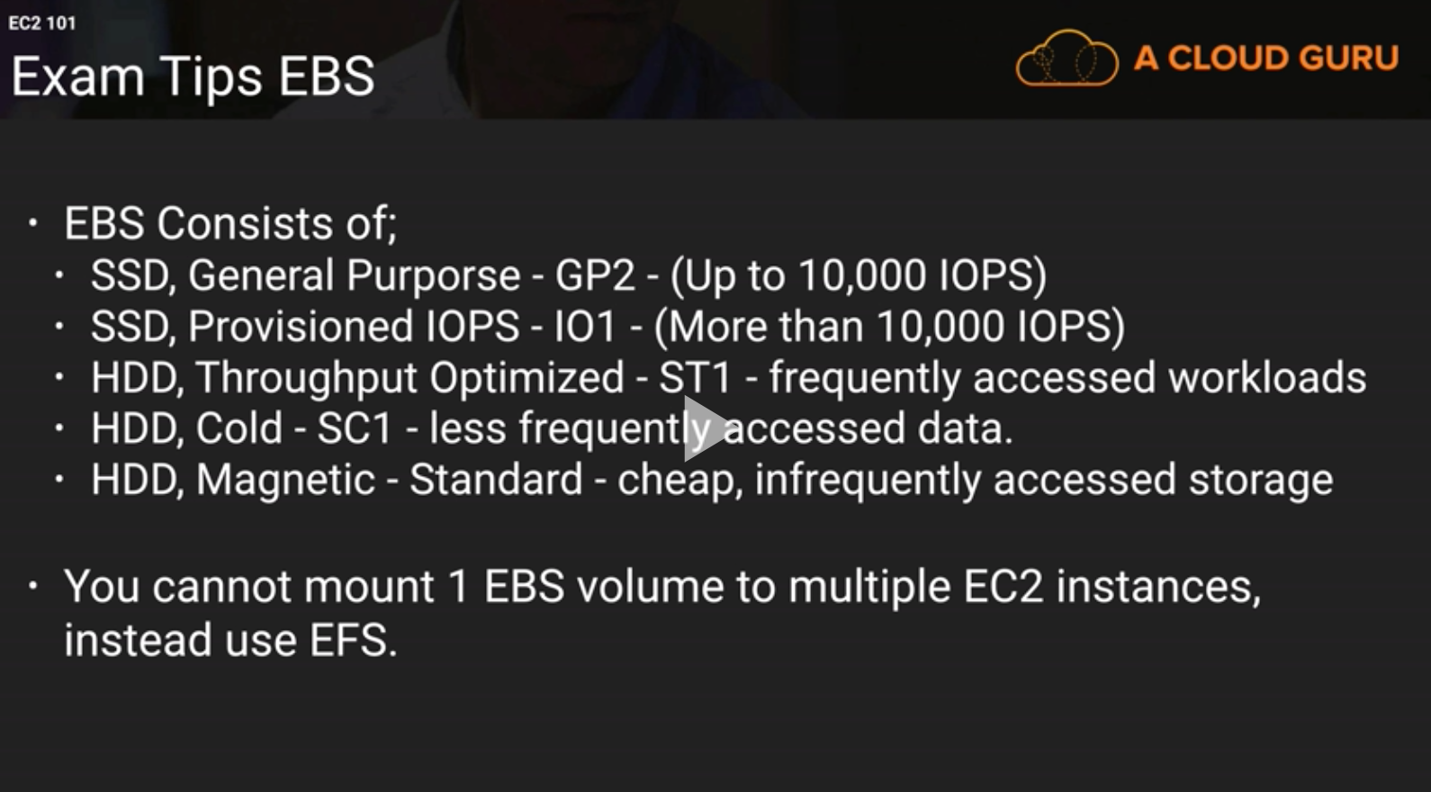

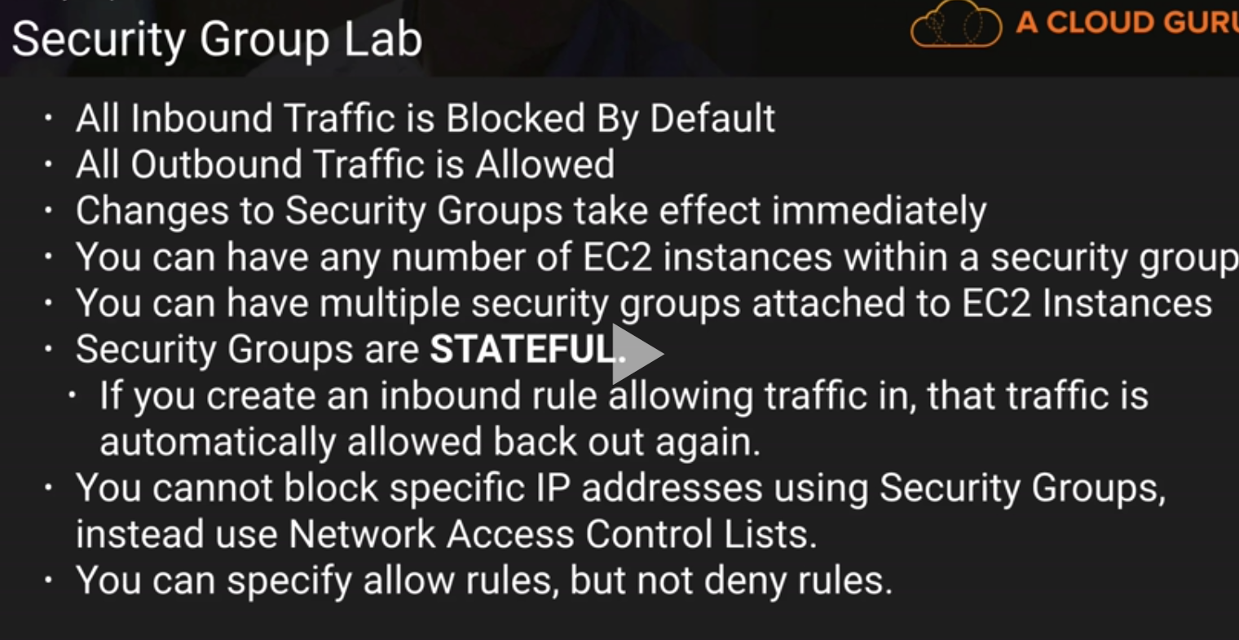

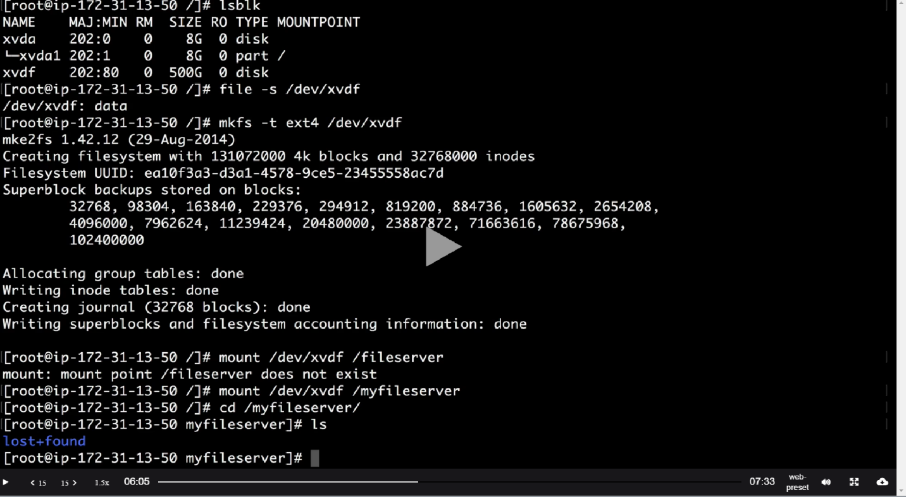

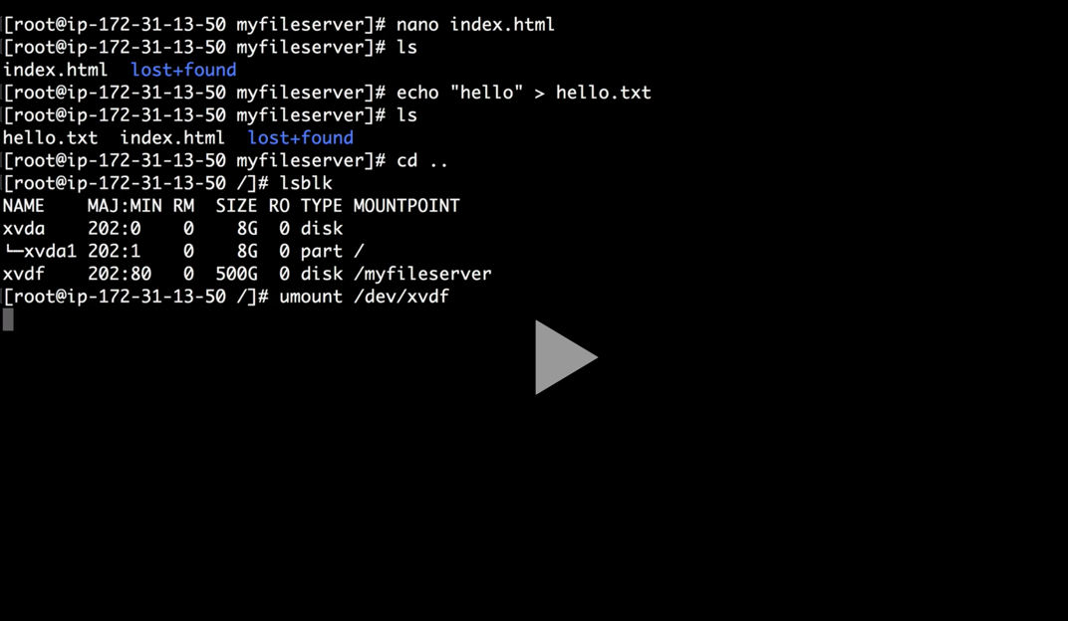

Sudo su

Lsblk – show volume info

File -s /dev/xvdf – to check if it has content

Mkfs -t ext4 /dev/xvdf – to format

Umount /dev/xvdf - Unmount

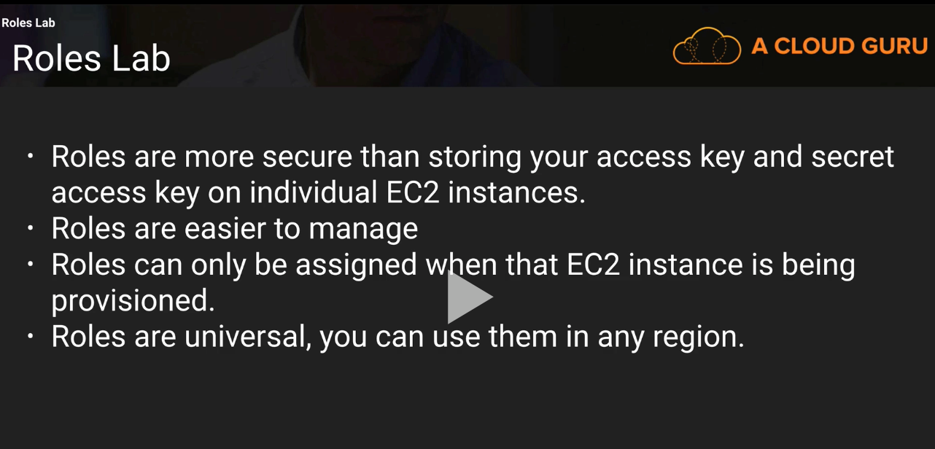

aws s3 ls – check s3 configuration

aws configure – configure AWS credentials. Enter access key, secret , region name(google to get the region name)

It will create a hidden .aws folder under root directory.

You can login to cd ~/.aws

aws ec2 describe-instances – describe your AWS instance

aws ec2 describe-images – describe your AWS images

aws ec2 run-instances – run instance

Can not change role or attach new role of existing EC2 instance. However you can change the policy of the role

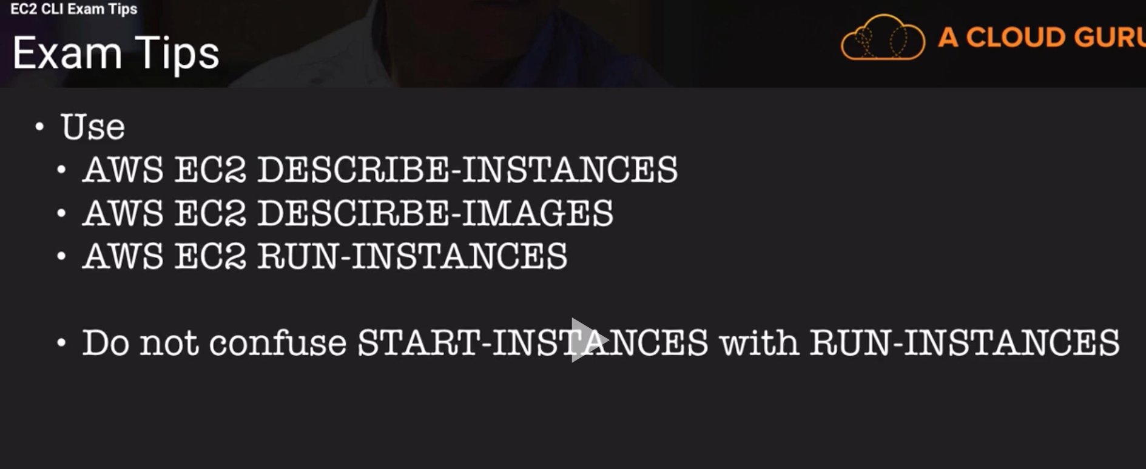

**Cli Commands**

Stop instance - aws ec2 stop-instances --instance-ids i-0ea7e27e3f510e2a5

Run/launch instances - aws ec2 run-instances --image-id ami-c58c1dd3 --count 1 --instance-type t2.micro --key-name myec2_key --security-groups ec2-securitygroup1

Terminate Instances –

aws ec2 terminate-instances --instance-ids i-0b579f1ee83a62cca

Get S3 buckets – aws s3 ls

Bash Script to Launch EC2

#!/bin/bash

yum update –y

yum install httpd -y

service httpd start

chkconfig httpd on

aws s3 cp s3://jit-s3/index.html /var/www/html

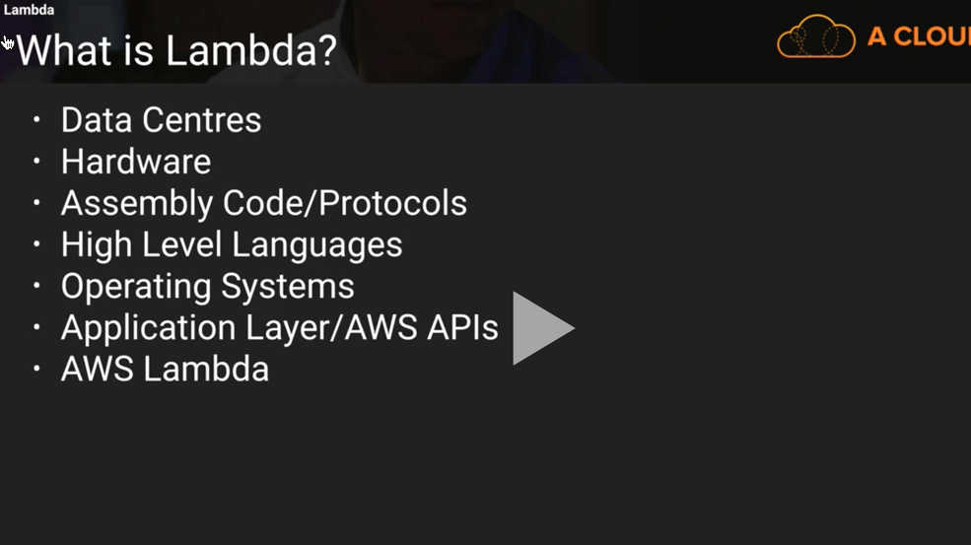

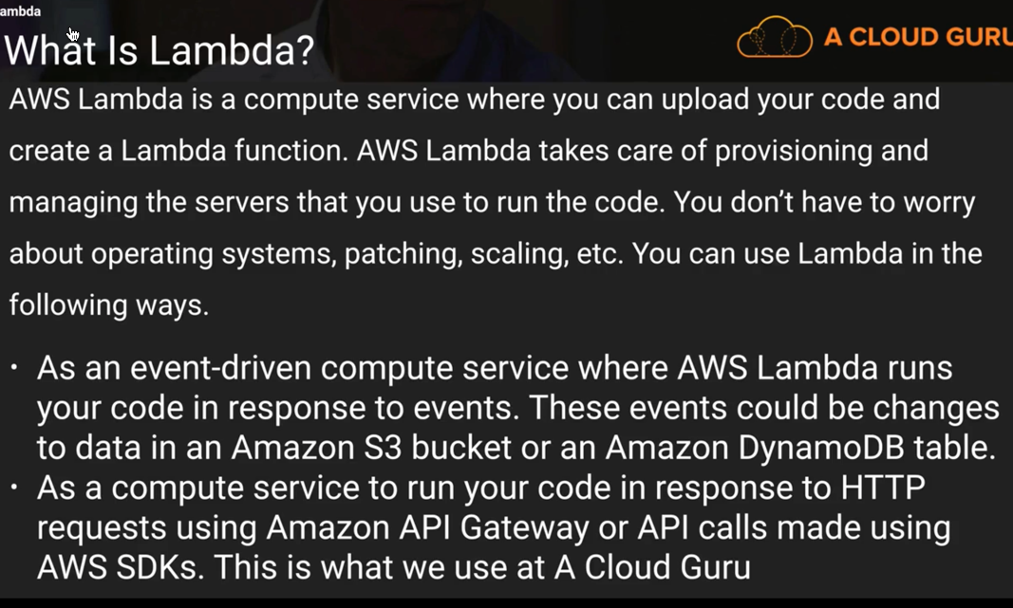

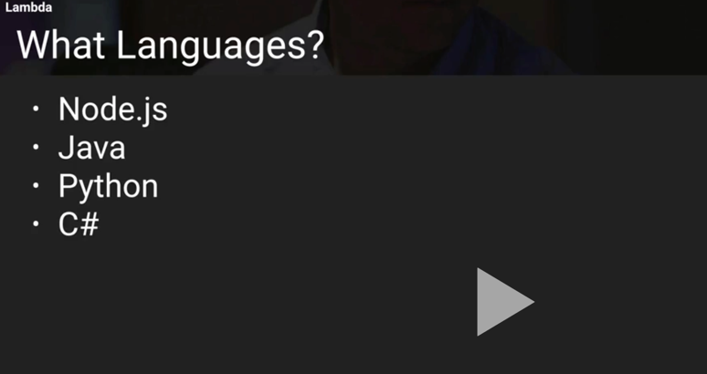

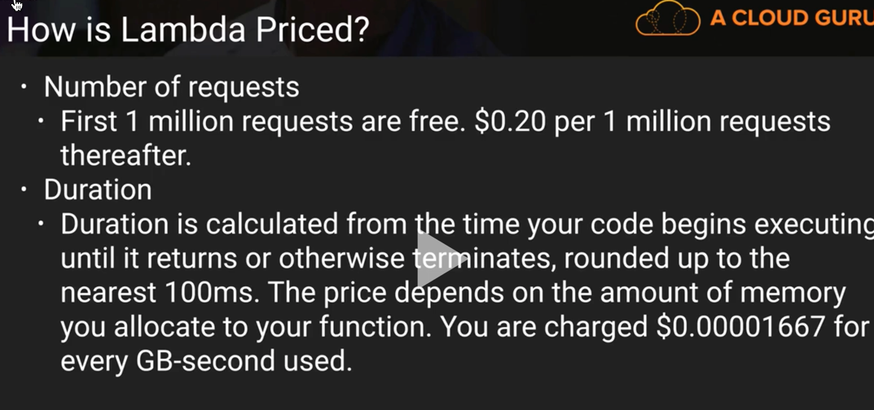

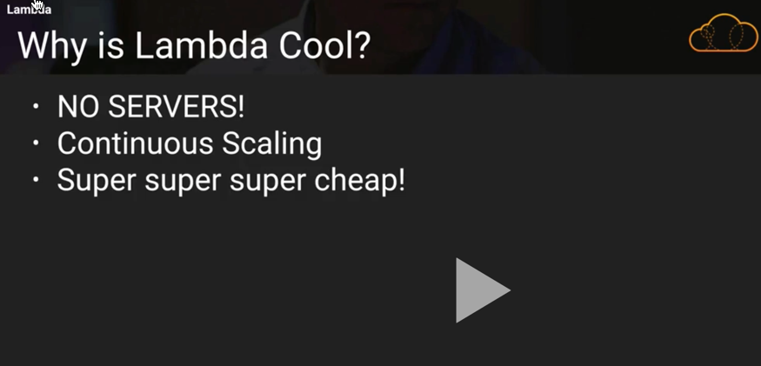

Instance Metadata - <http://docs.aws.amazon.com/AWSEC2/latest/UserGuide/ec2-instance-metadata.html>

get metadata – ssh to your ec2 and then issue this command –

curl <http://169.254.169.254/latest/meta-data>/

get public ip from metadata - curl <http://169.254.169.254/latest/meta-data/public-ipv4>

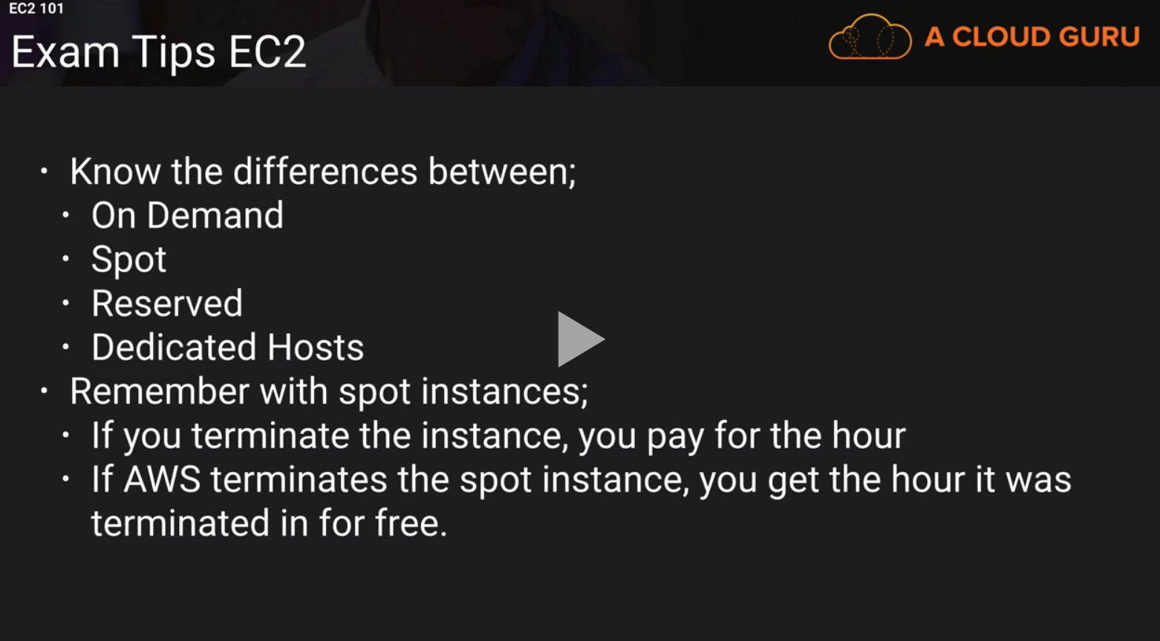

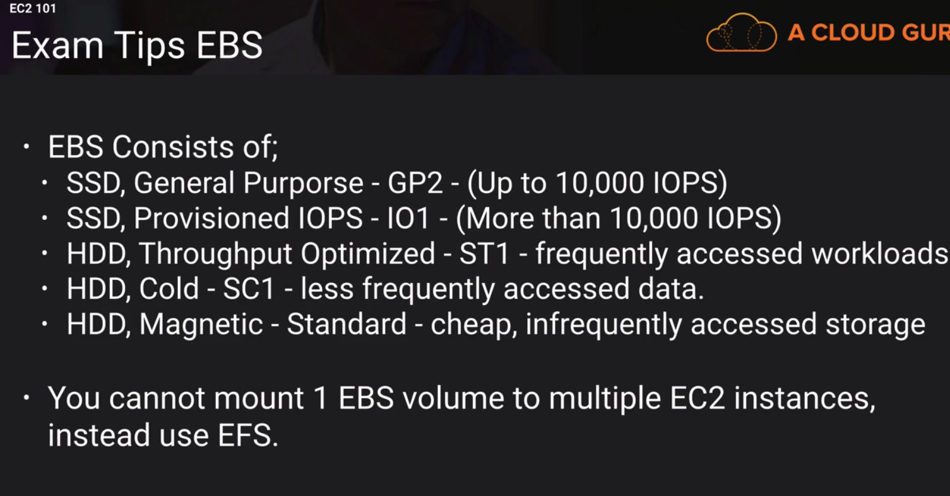

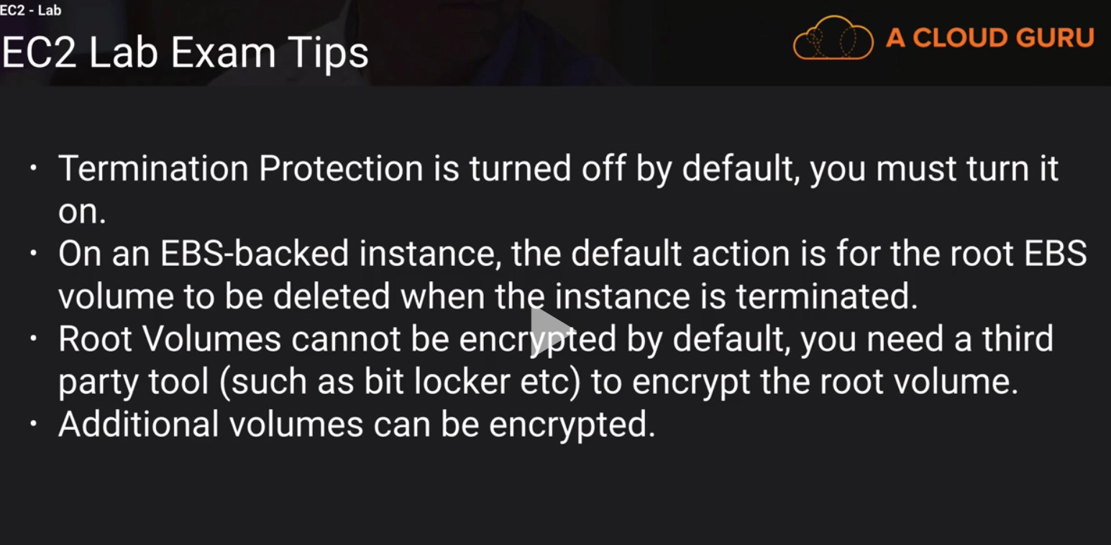

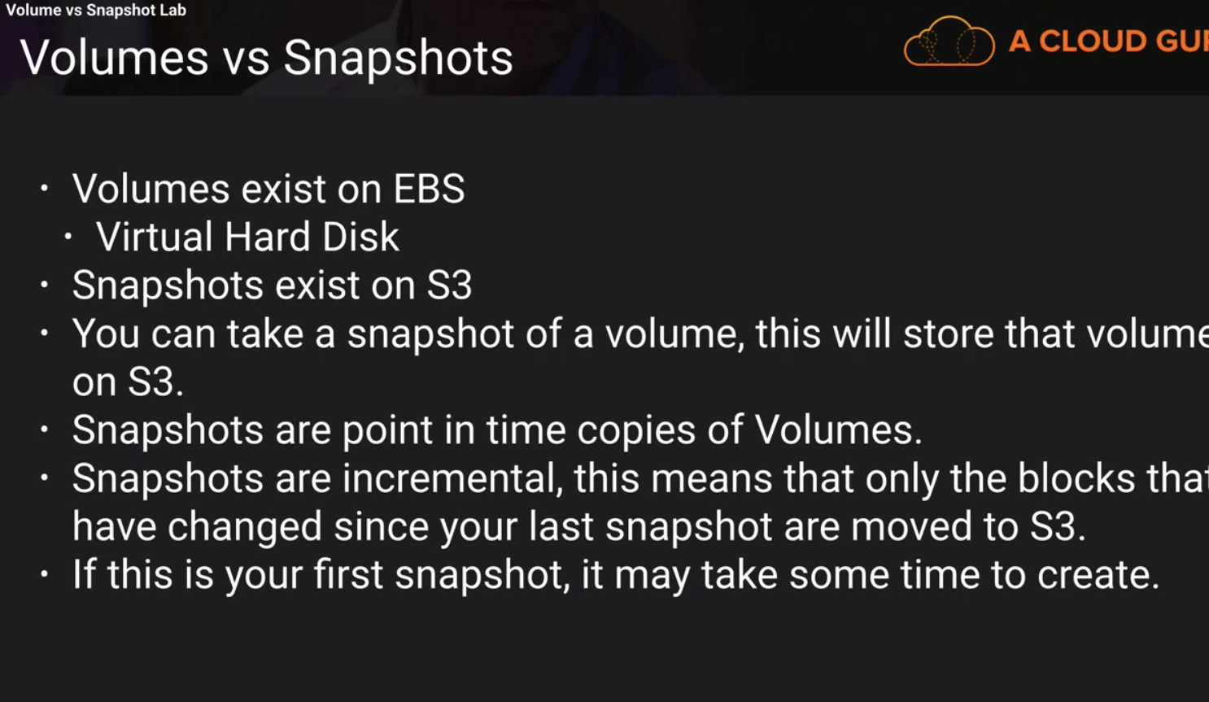

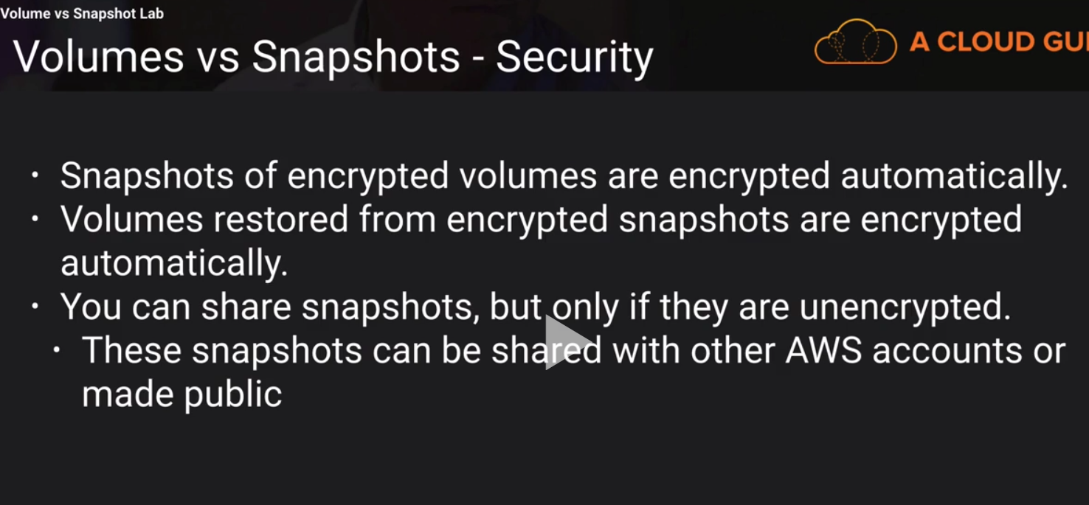

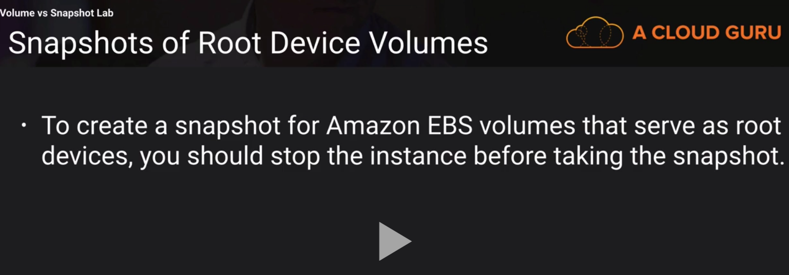

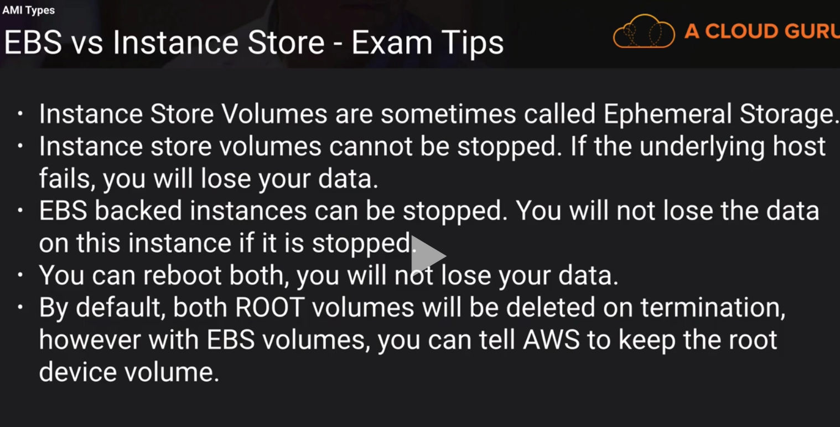

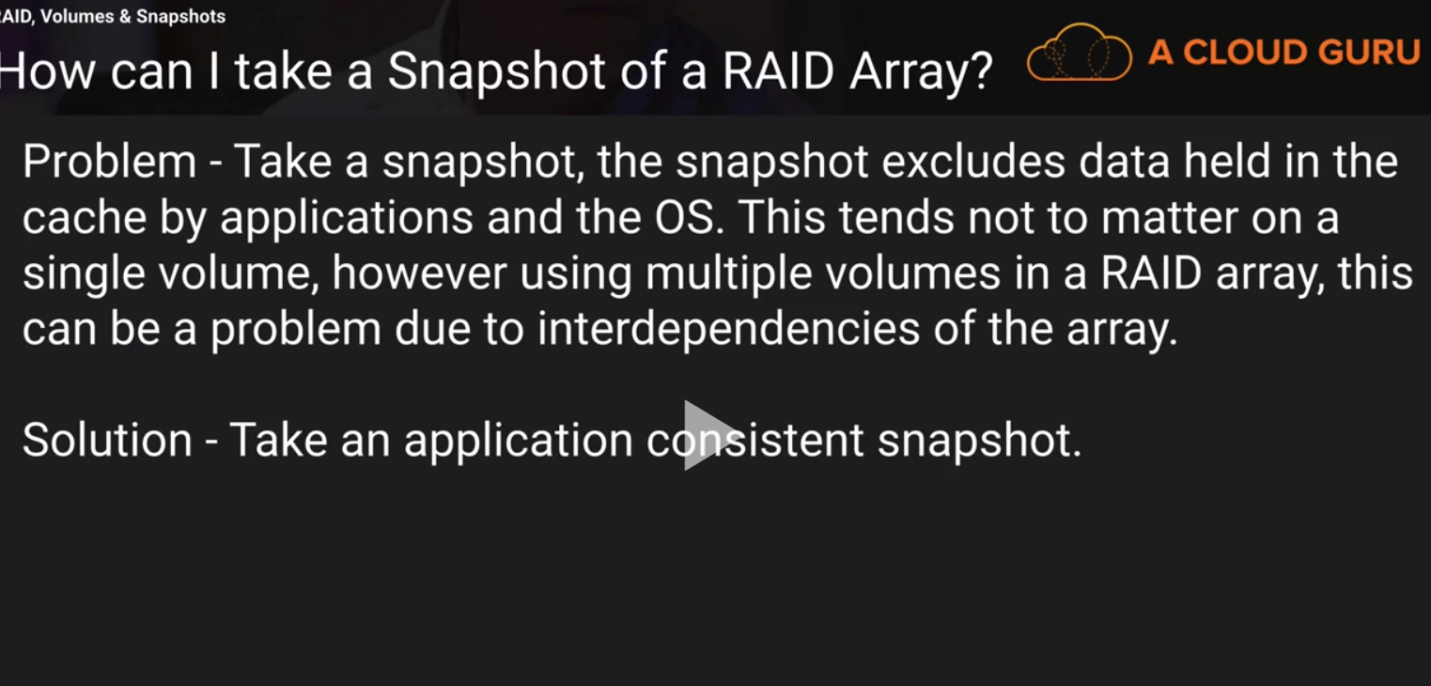

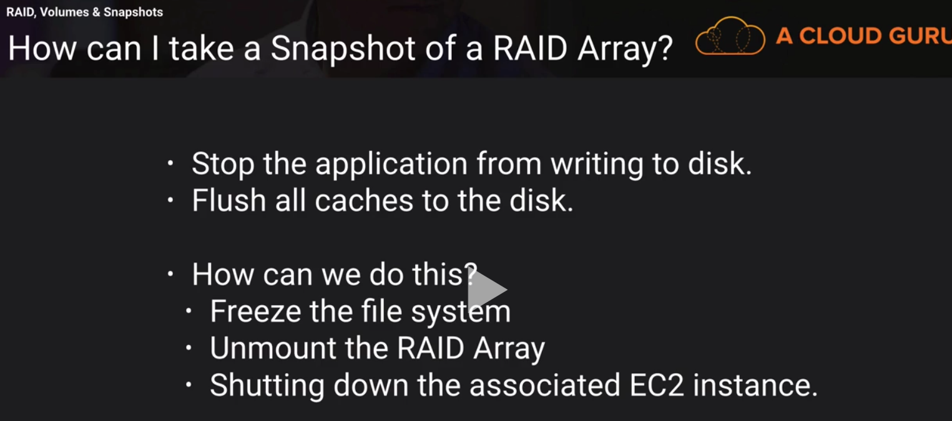

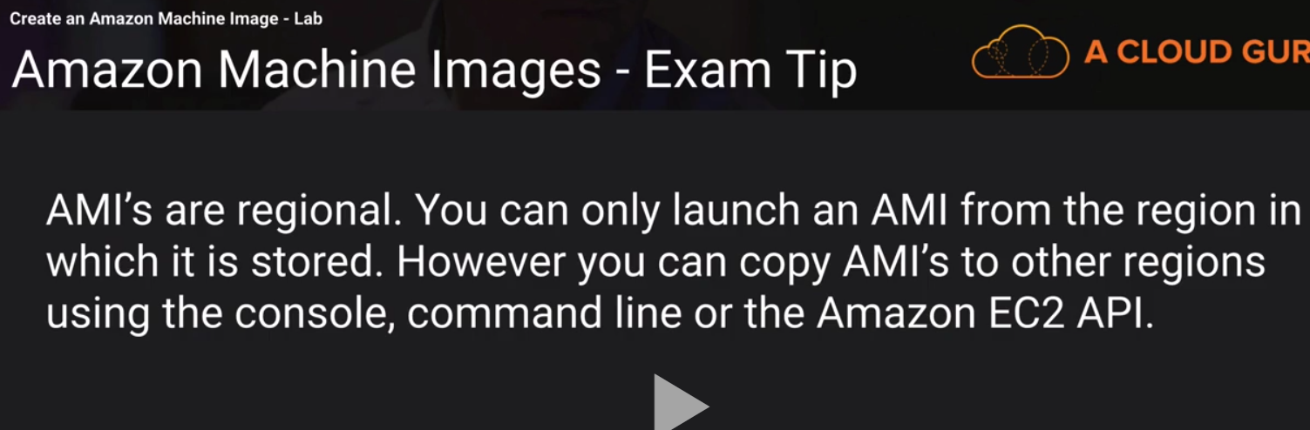

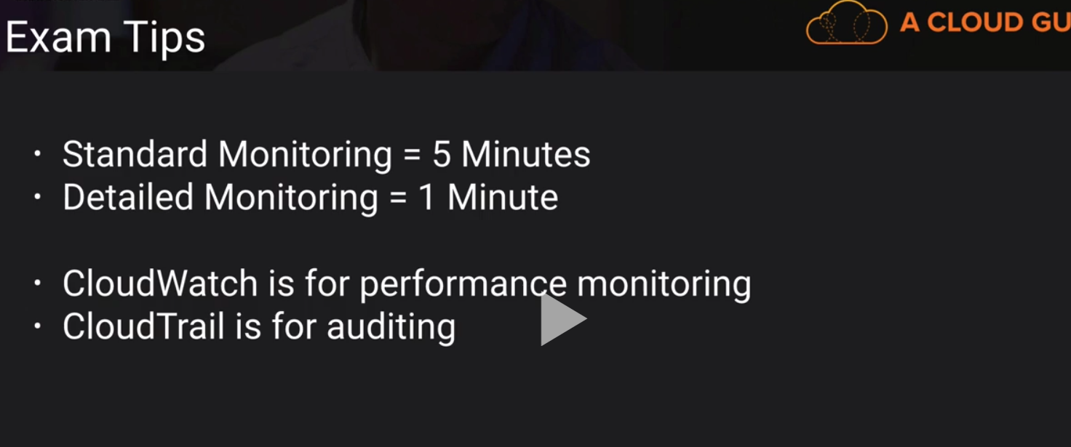

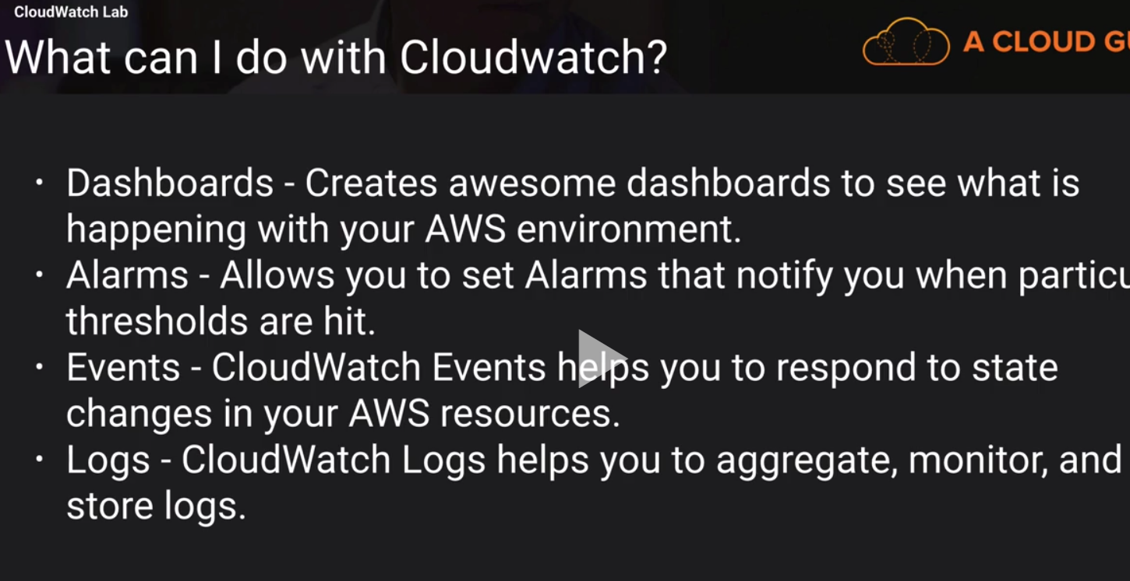

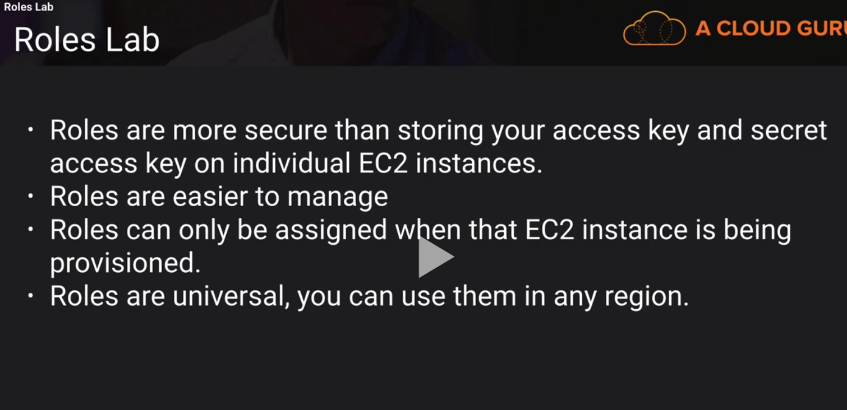

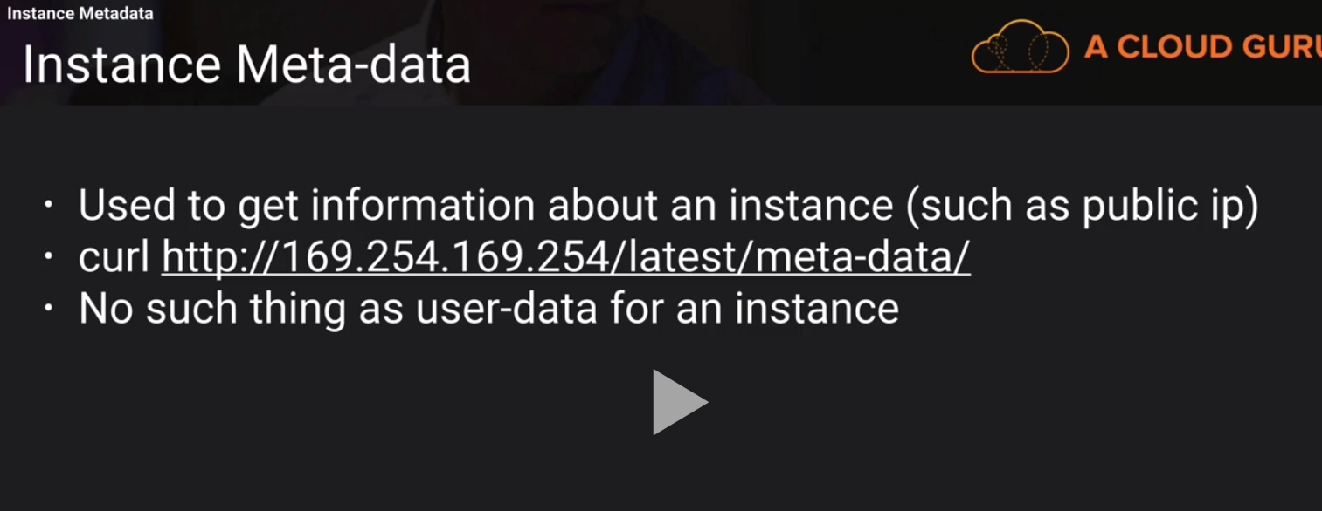

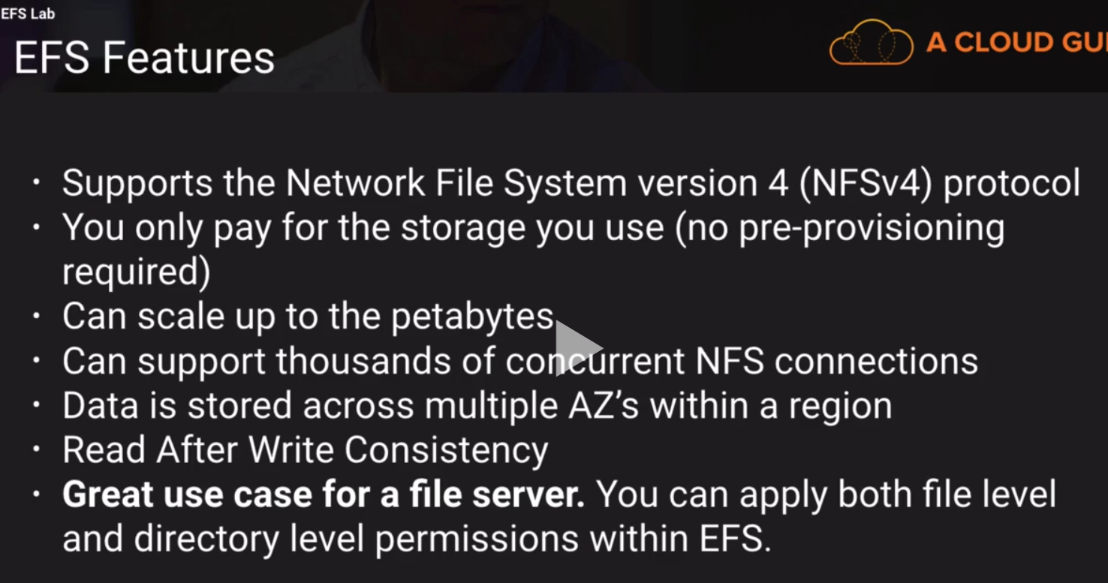

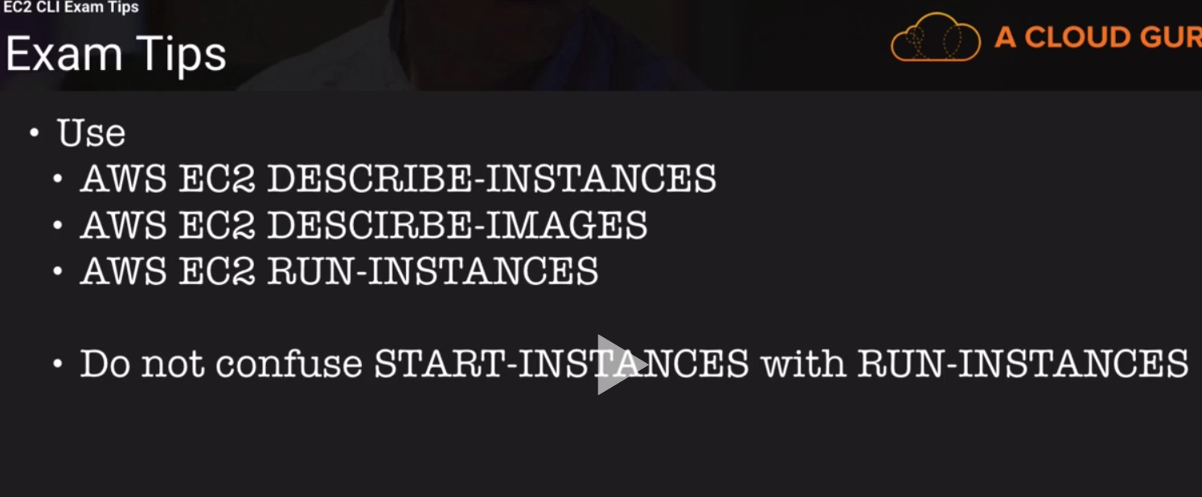

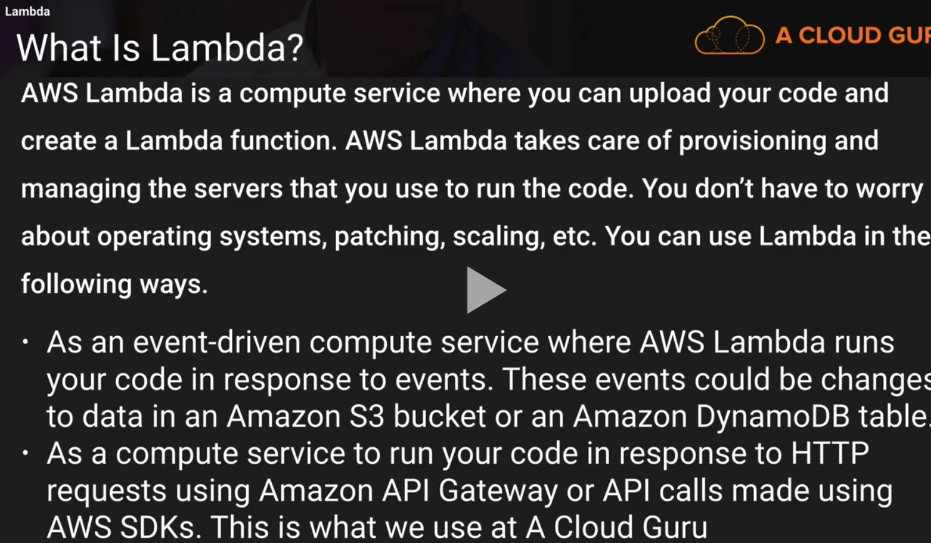

<https://aws.amazon.com/ec2/>

<http://docs.aws.amazon.com/AWSEC2/latest/UserGuide/Storage.html>